Tutorial 7: Basic Routing Concept

- Discuss the purpose of routing and the functions of a router.

- Determine which interface to use forward the packet to the destination.
- Determine the best path to forward packets based on the information in its routing to forward packets toward their destination.

- “Best path is selected by a routing protocol based on the value or metric it uses to determine the distance to reach a network.”

  - Explain the term “metric” in the given statement.

A value that is used to measure the distance to a given network.

  - Give examples of metric for each dynamic routing protocol as listed below.
    - Routing Information Protocol (RIP)

Hop count

    - Open Shortest Path First (OSPF)

Cisco’s cost based cumulative bandwidth from source to destination

    - Enhanced Interior Gateway Routing Protocol (EIGRP)

Bandwidth, delay, load and reliability

- With reference to the following network topology diagram (Figure 7.1), answer the questions:
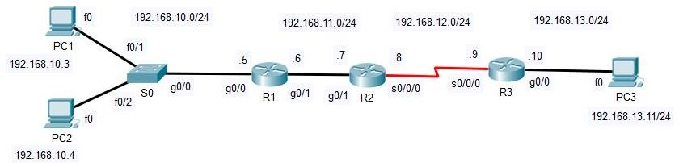

Figure 7.1 Network Topology
  - During the process of encapsulation, how does the PC1 determine the network address of the destination IP address of a packet?

- Subnet masking: If the destination IP belongs to the same subnet, it sends the packet directly to the destination.

  - When PC1 sends a packet to PC2, which intermediary device(s) is involved? Explain.

- Since PC1 and PC2 are connected to S0, the switch forwards the Ethernet frame from PC1 to PC2 based on MAC addresses.
- The switch learns MAC addresses dynamically and forwards the frame only to PC2, preventing unnecessary traffic.

  - When PC1 sends a packet to PC3, which intermediary device(s) is involved? Explain.

- Router R1 (default gateway)
- Router R2 (intermediate router)
- Router R3 (final router before PC3)

  - Fill in the information (Table 7.1) for R1. Assume that the network is already converged and the routing protocol used is RIP.
Network | Hops | Next-hop-IP | Exit Interface
192.168.10.0/24 | 0 (Direct) | Directly connected | g0/0
192.168.11.0/24 | 0 (Direct) | Directly connected | g0/1
192.168.12.0/24 | 1 | 192.168.11.7 | g0/1
192.168.13.0/24 | 2 | 192.168.11.7 | g0/1
Table 7.1 Routing Table information at R1
  - Fill in the information for R2 (Table 7.2). Assume that the network is already converged and the routing protocol used is RIP.
Network | Hops | Next-hop-IP | Exit Interface
192.168.11.0/24 | 0 (Direct) | Directly connected | g0/1
192.168.12.0/24 | 0 (Direct) | Directly connected | s0/0/0
192.168.10.0/24 | 1 | 192.168.11.6 | g0/1
192.168.13.0/24 | 1 | 192.168.12.9 | s0/0/0
Table 7.2 Routing Table information at R2

  - Fill in the information for R3 (Table 7.3). Assume that the network is already converged and the routing protocol used is RIP.
Network | Hops | Next-hop-IP | Exit Interface
192.168.12.0/24 | 0 (Direct) | Directly connected | s0/0/0
192.168.13.0/24 | 0 (Direct) | Directly connected | g0/0
192.168.10.0/24 | 2 | 192.168.12.8 | s0/0/0
192.168.11.0/24 | 1 | 192.168.12.8 | s0/0/0
Table 7.3 Routing Table information at R3

- Answer the following questions based on the routing table shown in Figure 7.2.
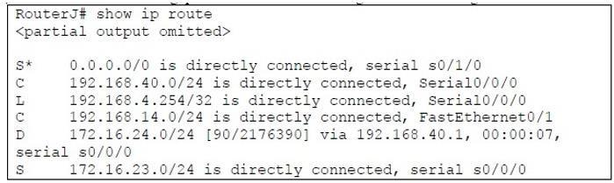
Figure 7.2: Routing Table of RouterJ

  - Identify the directly connected network(s).

- 192.168.40.0/24
- 192.168.14.0/24

  - Identify the remote network(s). Include the dynamic routing protocol used by RouterJ in your answer.

- 172.16.24.0/24
- 172.16.23.0/24
  - Explain the value [90/2176390] for the route with letter “D”.

- 90: Administrative Distance of the route. It is a measure of the trustworthiness of a routing protocol. Lower values indicate higher trustworthiness. 90 is default administrative distance of EIGRP.
- 2176390: Metric of the route. It is a composite value calculated based on several factors such as bandwidth, delay, reliability, load and MTU. It is used to determine the best path to a destination network.

  - Differentiate between the route with the “S*” and “S” indicators.

- The "S*" indicator denotes a static default route. The asterisk (*) designates it as a candidate default route, which is used when no other specific routes match the destination IP address.
- Default routes are typically used to forward packets to a next-hop router when the destination is outside the known networks listed in the routing table.

- The "S" indicator identifies a manually configured static route. This type of route is added by the network administrator to direct traffic to a specific destination.
- Static routes are used for predictable, fixed paths in the network where dynamic routing is unnecessary or undesirable.

  - RouterJ received a packet with destination IP address 192.168.25.100/24. Describe the routing decision made by RouterJ.

- Direct Match Lookup:
  - The router first checks its routing table for a network that directly matches the destination network, 192.168.25.0/24.
  - In this case, there’s no entry for 192.168.25.0/24 in the routing table.
- Default Route Fallback:
  - Since there is no direct match, the router will fall back to the default route, which is marked as: S* 0.0.0.0/0 is directly connected, serial 0/1/0
  - This means that any packet destined for an unknown network (like 192.168.25.100) will be sent out through serial interface s0/1/0.

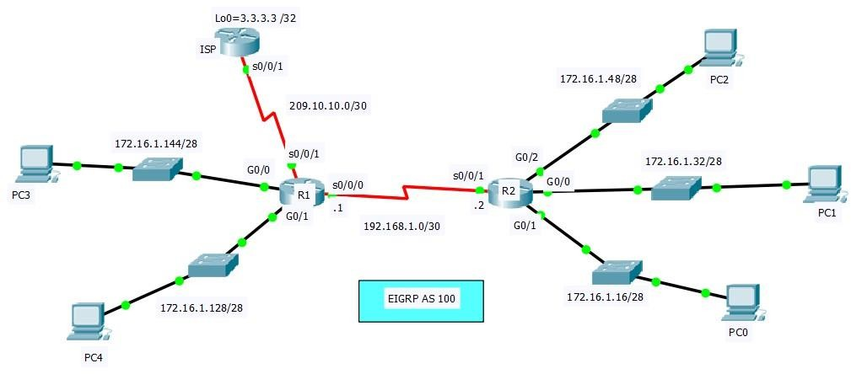

- As the network administrator of a company, Ali is troubleshooting EIGRP and static route problems on either router R1 or R2 for a network topology shown in Figure 7.3.
Identify and rectify FOUR (4) problems with the configurations shown in Figure 7.4 to ensure the respective routers are able to establish adjacencies among themselves and all the PCs are able to ping Loopback0 (Lo0) in the ISP router. Provide your explanations when identify and rectify any problems. Assume configurations in ISP are correct. Document the configuration errors and give correct solutions using Table 7.4 in your answer.

Figure 7.3: An EIGRP network topology

R1#show run hostname R1  interface GigabitEthernet0/0  ip address 172.16.1.145 255.255.255.240  interface GigabitEthernet0/1  ip address 172.16.1.129 255.255.255.240  interface Serial0/0/0  ip address 192.168.1.1 255.255.255.252  clock rate 128000  interface Serial0/0/1  ip address 209.10.10.1 255.255.255.252  router eigrp 100  network 172.16.1.144 0.0.0.15  network 172.16.1.128 0.0.0.15  network 192.168.1.0 0.0.0.3 | R2#show run hostname R2  interface GigabitEthernet0/0  ip address 172.16.1.33 255.255.255.240  interface GigabitEthernet0/1  ip address 172.16.1.17 255.255.255.240  interface GigabitEthernet0/2  ip address 172.16.1.49 255.255.255.240  interface Serial0/0/1  ip address 192.168.1.2 255.255.255.252  router eigrp 110  network 172.16.1.48 0.0.0.15  network 172.16.1.16 0.0.0.15  network 192.168.1.0 0.0.0.3
Figure 7.4: output from “show run” command in respective routers

Problems | Solutions
Mismatched EIGRP Autonomous System Numbers | router eigrp 100
Non-matching Network Statements for Connected Interfaces on R2 | network 172.16.1.32 0.0.0.15
Missing default static route on R1 | ip route 0.0.0.0 0.0.0.0 s0/0/1  OR  ip route 0.0.0.0 0.0.0.0 s0/0/1  router eigrp 100  redistribute static (inform R2 to know R1's default route, so R2 no need to set the static route again)
Missing default static route on R2 | ip route 0.0.0.0 0.0.0.0 s0/0/1  OR  ip route 0.0.0.0 0.0.0.0 192.168.1.1
Table 7.4: Documentation Table

